PHY 2053C Spring 2019 MC Exam #1 Name: __________________________________

1. In which graph of v versus t  does the particle end up closest  to its starting point?  A) 1 B) 2 C) 3  D) 4 E) 5 | 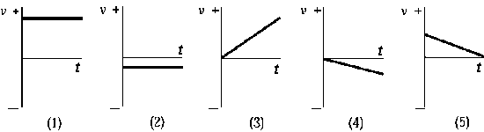

2. On a graph that shows position on the vertical axis and time on the horizontal axis, a straight line
with a positive slope represents
A) constant positive acceleration. C) zero velocity.
B) constant negative acceleration. D) constant positive velocity E) constant negative velocity.

3. The graph shows the displacement of a particle along  the y axis as a function of time. The points at which  the velocity is the same are  A) A and C. B) A and E. C) B and D.  D) A, C, and E. E) B, C, and D. | 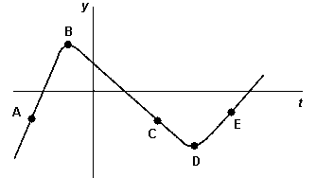

4. A Ford truck enters a highway and travels at a uniform speed of 50 mph. Half an hour later a
Jaguar enters the highway at the same junction and heads in the same direction at 55 mph. How
long after the Ford entered the highway does the Jaguar catch up with the truck?

A) 5.0 hrs B) 6.0 hrs C) 1.0 hrs D) 1.6 hrs E) 5.5 hrs

5. A vehicle is traveling in the -x direction to x = 100 m. It then reverses direction. At the instant
when it changes direction, the acceleration of the vehicle is

A) positive. B) negative. C) zero. D) positive then negative. E) negative then positive.

6. An object is dropped from rest near the surface of Earth. If the time interval during which it falls
is cut in half, the distance it falls will
A) double. B) decrease by one-half.
C) increase by a factor of four. D) decrease by a factor of four. E) not change.

7. A projectile is fired vertically upward with a speed of 62 m/s. In the absence of air resistance, the
maximum height the projectile attains is

A) 25 km B) 98 m C) 200 m D) 19 km E) 3 m

8. An object is at x = –3 m and has a velocity of 4 m/s. It is observed to be slowing down. Its
acceleration is
A) positive. B) negative. C) zero.
D) negative until the object stops and then positive.
E) impossible to determine based on the information provided.

9. A balloon is ascending at a rate of 16 ft/s at a height of 32 ft above the ground when a package is
dropped. The time taken, in the absence of air resistance, for the package to reach the ground is

A) 1.0 s B) 1.5 s C) 2.0 s D) 2.5 s E) 3.0 s

10. You walk 12 km south and then 5 km east. Your resultant displacement is

A) 13 km at an angle of 22.6º south of east. B) 13 km at an angle of 67.4º south of east.
C) 17 km at an angle of 22.6º south of east. D) 17 km at an angle of 67.4º south of east.
E) None of these is correct.

11. A projectile is fired at an angle of 45º above the horizontal. If  air resistance is neglected, the line in the graph that best  represents the horizontal displacement of the projectile as a  function of travel time is  A) 1 B) 2 C) 3 D) 4 E) None of these is correct. | 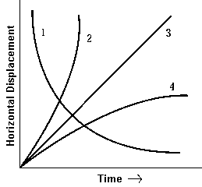

12. Which of the following statements is not true of a projectile moving near the surface of the earth
against negligible air resistance?

A) The horizontal velocity is constant. B) The vertical acceleration is constant.
C) The horizontal displacement is directly proportional to the time of flight.
D) The vertical velocity at any given time is independent of the angle of projection.
E) The horizontal acceleration is constant.

13. A stone with a mass m is dropped from an airplane that has a horizontal velocity v at a height h
above a lake. If air resistance is neglected, the horizontal distance R from the point on the lake
directly below the point of release to the point where the stone strikes the water is given by
which formula? A) R = v(2h/g)² B) R = (1/2)gt² C)
D) E) None of these is correct.

14. A projectile is shot at an angle of 45º to the horizontal near the surface of Earth but in the
absence of air resistance. When it reaches the highest point of its trajectory, its speed is 150
m/s. In a second trial with the same projectile, the initial speed is the same but the angle is now
37º with the horizontal. At its highest point in this trajectory, the speed of the projectile would be
A) 150 m/s (sin 45º/sin 36º) B) 150 m/s (cos 37º/cos 45º)
C) 150 m/s (sin 37º/sin 45º) D) 150 m/s (37/45) E) None of these is correct.

15. You shoot an arrow in a high arc toward a target located some distance away. At the highest
point in its flight, the arrow's
A) velocity and acceleration are both nonzero.
B) velocity is zero but its acceleration is nonzero.
C) velocity is nonzero but its acceleration is zero.
D) velocity and acceleration are both zero.
E) Insufficient information is given to answer correctly.
16. The figure represents the parabolic trajectory of a ball going  from A to E in Earth gravity but without air resistance. What  is the direction of the acceleration at point C?  A) it is to the right B) it is to the left  C) it is straight up D) it is straight down  E) The acceleration of the ball is zero | 